Smart Glove

Shawn D’Souza  Student  Flat no XF 8  Sunset Boulevard  Altinho Mapusa  Goa – India  +91-9158804277  shawnelec@gmail.com | Aniruddh Gawade  Student  C-2-D  All India Radio Colony  B.B. Borkar Road country  Porvorim Goa – India  +91-9423889600  aniruddhgawade@gmail.com | Siddesh Gad  Student  R.H.6  Sayyadri Enclave A  Durgabhat Upper Bazar  Ponda Goa – India  +91-9923247149  sidgad777@gmail.com | Ms. D.S. Vidhya  Guide  Asst. Prof.  IT Dept.  S.R.I.E.I.T.  Shiroda-Goa  +91-9552754115 dsvidhya@yahoo.co.in

ABSTRACT
Our project is designed to help the unfortunate people who cannot speak to communicate with us. The project consists of a glove equipped with flex sensors that will be worn by the person. A portable screen in the form of a badge will also be worn by the person. In case the need arises to communicate, the person will have to just make the signs corresponding to ASL (American Sign Language) symbolizing the various characters to form words and those words will be displayed on a graphical LCD.
The system works by sensing the voltage drop across the flex sensors. This is then fed to the ADC input of the microcontroller. Here sampling is done and the digital values are stored (when unit is used for the first time), corresponding to each character. In this way the microcontroller learns the characters. When the sign is done again, these values are compared against the reference values in order to obtain the characters and pattern matching is done. The characters are transmitted to another microcontroller. These characters or words are sent to the display driver. The display driver then outputs the character or word on the portable screen.
The Smart Glove is multi-faceted. There are added facilities to control the mouse of a computer via an accelerometer mounted on the glove and also to use it to input text to the computer just like a keyboard! The receiver unit is connected to the serial port of the computer and PS2 port. The user just switches between the text and mouse mode to use it as a mouse or keyboard. The right and left click is done by moving the index and middle finger just like an ordinary ‘click’ action!

"Permission to make digital or hard copies of part or all of this work for personal or classroom use is granted without fee provided that copies are not made or distributed for profit or commercial advantage and that copies bear this notice and the full citation on the first page. Copyrights for components of this work owned by others than IJCA must be honored. Abstracting with credit is permitted. To copy otherwise, to republish, to post on servers or to redistribute to lists, needs an acknowledgement to IJCA."

When the user changes the mode to wireless control, he/she will be able to control his/her home appliances with only the glove. The glove acts as a master remote control where each character or combination of characters will represent a specific appliance. This too can be changed or set by the user. The slave unit is made up of another microcontroller that is wired to the appliance via a driver IC and relays.
General Terms
This project deals with pattern matching. We have used Knuth Morris Pratt Algorithm in order to accomplish this. For drawing graphics on the LCD, we used simple Computer Graphic drawing algorithms like mid-point circle and ellipse drawing algorithm, DDA line drawing algorithm.
Keywords
Smart Glove: This refers to the glove with flex sensors mounted on each finger and accordingly linked to a microcontroller with a keypad for control. It has 4 basic modes: sign to text conversion, remote control of appliances, mouse control and text input for computer.
Multiple Sampling: This refers to the technique of taking many samples at an instant of time and then analyzing each sample to find how much of a desired pattern is found in those samples. Accordingly the probability of a match is calculated. If it is high then the pattern is the desired one if low then it is the wrong one! This technique increases the accuracy and of the outcome.

INTRODUCTION
Consider a scenario in which a person who cannot speak is waiting for bus at the bus stop and wants to ask about the bus timings. How would he communicate in sign language with another person who does not understand sign language? This sparked off the idea behind our project: to design a portable language translator that would convert this sign language into an understandable language (English).
In this project, we have a glove and a portable display which will be worn by the handicapped person who cannot speak. On this glove, we mount flex sensors that sense the bends in the fingers of that person. Proportional to the amount of bend, the resistance of the flex sensor increases. The flex sensors are connected to the microcontroller ADC input port.
The analog voltage difference change across the flex sensor is then converted into digital form by the ADC present in the microcontroller. Here the digital values are stored for future pattern matching. When a sign is made, pattern matching is done and if the probability of match is high, it is taken as that character. This is then displayed on the portable LCD screen. (Figures 1 and 2)
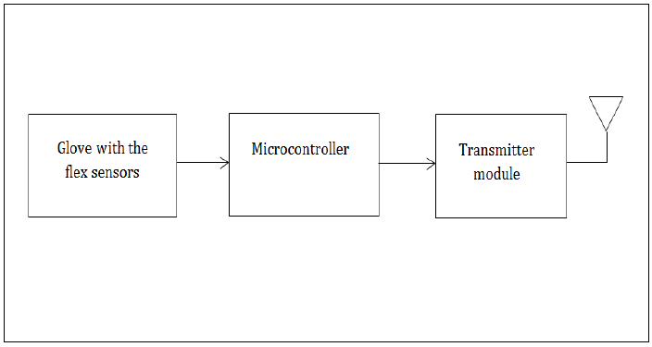
Figure 1: Block diagram of the transmitter unit

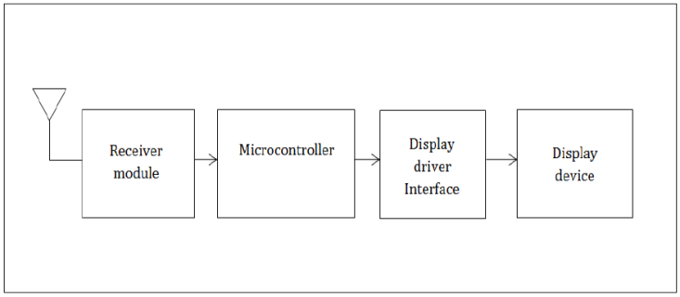
Figure 2: Block diagram of the receiver unit
When the mode is changed to ‘mouse and keyboard’, the glove acts as a remote keyboard and mouse. The receiver is connected to the computer’s serial port. When the glove is waved in the air, an accelerometer present on the glove senses the hand motion and accordingly an analog voltage is generated. Based on this, the mouse pointer is moved on the screen. Right or left ‘click’ is done the normal way with the index and middle finger. To act as a keyboard, the user has to just make the signs and the character will be sent to the computer instead of being displayed on the LCD.

HARDWARE USED

Flex Sensors

Microcontroller ATmega 32

Graphic LCD 128x64 (128G064E)

CC2500 wireless transceiver module

4 x 4 keypad

Accelerometer ADXL 335

I.C. EM84510F (PS2 mouse controller)

SOFTWARE

The Glove Transmitter Unit
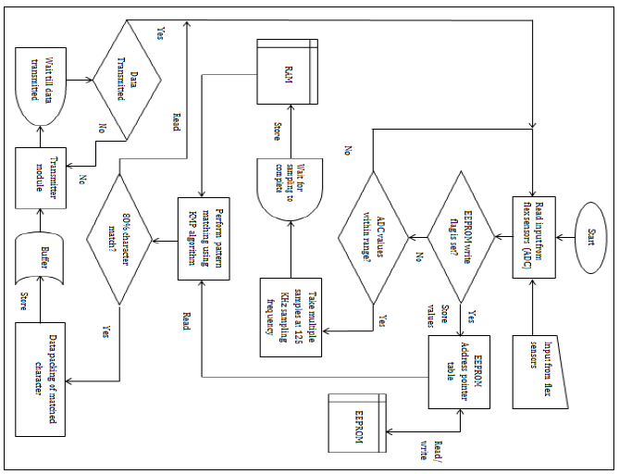
Figure 3: The Glove Transmitter Unit Flow Chart (for sign to text mode)
The system works on the real time samples taken and pattern matched with the already stored samples. Multiple samples are taken and the probability of an approximate match is calculated. Taking the probability of multiple samples reduces error and increases the probability of success of a match. When the user first wears the glove, the unit does not know the bend values of his/her fingers as nothing is stored in the EEPROM. Hence the unit first checks if there are values stored in the EEPROM before proceeding with pattern matching. If samples are already stored in the EEPROM, the EEPROM write flag is set. Hence the unit can proceed with the pattern matching. If the flag is reset (i.e. 0) then the unit asks the user to store the samples corresponding to each letter before proceeding.
For real-time pattern matching, the unit checks if the ADC sampled values are within a preset range. If these values lie within that range, the unit then starts to take multiple samples of the voltage drop values. The ADC has a sampling frequency of around 125 KHz. This frequency is enough to give us around 100 samples in about a millisecond. We have to wait till sampling is complete and hence a small delay is introduced.
Next the KMP algorithm is executed and the values are read from the EEPROM and matched against the values stored in the RAM. If there is a 80% or more probability of a character match, then that character is returned as the matched character. A ± 10 difference between the patterns matched is tolerated. This is done so as to compensate for the errors in sampling and physical sensor defects. If no match is found it repeats the sampling process. This character is packed along with its checksum and a flag byte. Before transmission, the data is buffered and then is transmitted via the SPI port.
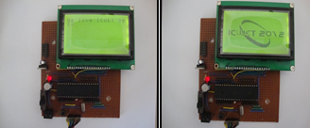
Figure 4: Text and image display on the Graphic LCD

The Receiver Unit (for the sign to text or number mode)
At the receiver‘s end, the data is read via the SPI port. The read data from the register is buffered. The data is then unpacked and the packed is checked for a valid flag and checksum. If the checksum is good then the data is returned. Each character (data) is sent to the display driver software.
A character match of the ASCII value against the font array index is done. The font array is arranged so that the ASCII value of each character corresponds to the respective bit value in that index location of the array. Since the graphic LCD is divided into 8 x 8 pixels for each character, the font array is read for 8 consecutive locations, with each location containing 8 bits data. Once the character bitmap is returned, the data is sent to the Graphic LCD data port for display. (Figure 5)
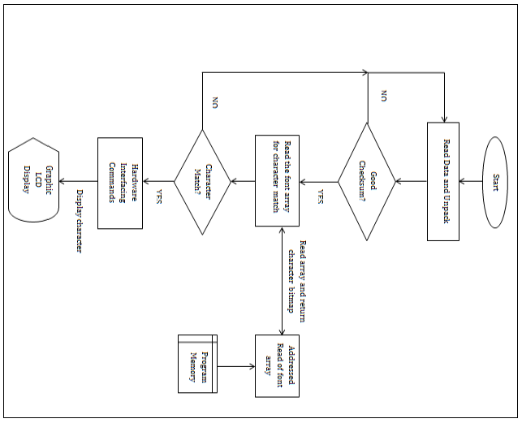
Figure 5: The Receiver Unit Flow Chart

Mouse and keyboard mode
For the keyboard mode, the characters received by the unit are transmitted via the serial port to the computer. On the computer is installed small software that accepts the character and displays it on the computer screen. For the unit to act as a mouse, an accelerometer installed in the glove converts the movement of the hand into analog voltages. These voltages are fed to the ADC input of the microcontroller in the glove. The digital values are then data packed with a checksum and sent wirelessly to the receiver unit.
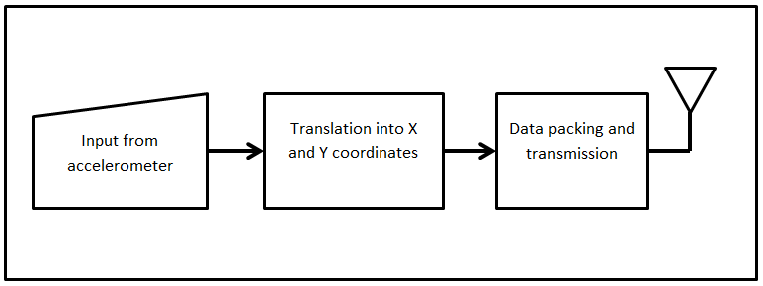
Figure 6: The Glove Transmitter Unit for mouse mode (Block diagram)
The receiver unit consists of a microcontroller whose output is linked to the I.C. EM84510F (PS2 mouse controller) X-Y input pins. A small code is written for the microcontroller to convert these analog voltage values to the corresponding X-Y motion. The PS2 mouse controller then controls the mouse pointer on the screen like a normal mouse. For the right click and left click, the flex sensors on the index and middle finger are employed. An analog threshold value is set for the left and right ‘click’ buttons in microcontroller of the transmitter module. When it is crossed a click code signal is sent to the receiver. The receiver accordingly controls the PS2 controller to emulate a right ‘click’ or left ‘click’ of a mouse.
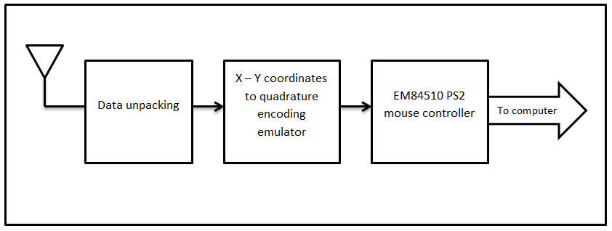
Figure 7: The Receiver Unit (Block Diagram)

Wireless remote control
In this mode, the glove acts as a wireless control for the appliances. For the first use, the user makes the signs corresponding to each device he wishes to control. These signs are mapped in the EEPROM corresponding to each device. Hence when the sign is made the next time, it is pattern matched just like the in text mode and transmitted to a receiver unit.
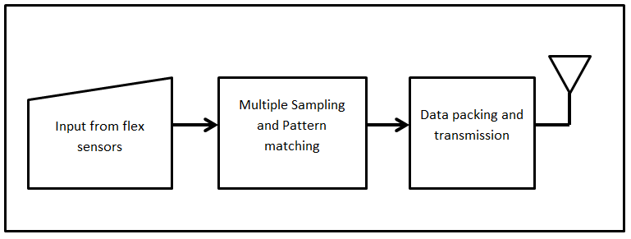
Figure 8: The Glove Transmitter Unit for Appliance Control (Block diagram)
On the receiver’s end, the microcontroller ports are configured accordingly to act as normal outputs for controlling the appliances. These are linked to a ULN2003 driver I.C. to drive relays to control the user’s loads/appliances that operate of 230VAC.
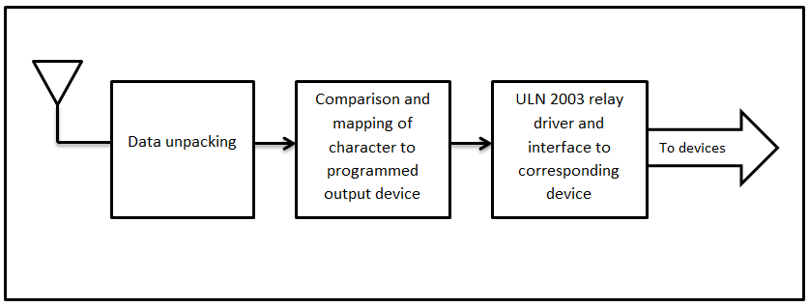
Figure 9: The Receiver Unit for Appliance Control (Block diagram)

Software and Hardware Tools
- AVR Studio 4
- AVRdude
- Visual Studio 2008

SYSTEM FEATURES
- With machine learning, the user can train the unit to adapt to his/her own hand.
- Faster and better character recognition by using multiple sampling.
- Character displayed vividly on the display.
- Portability: can be used anywhere
- Provision for other language support
- Provision for image support
- Battery operated and safe to use
- The unit can act as a mouse and keyboard input for a computer.
- Controlling of home appliances also possible just by making signs.

SYSTEM ANALYSIS
- The bend resistance offered by the flex sensor ranges from 45KΩ to 125KΩ. This gives a potential difference across the flex sensor of around 2.5V to 3.676V respectively. (When connected with a voltage divider with 45KΩ to Vcc and the flex sensor to Gnd.)
- This gives an 8-bit ADC value range from 128 to 188 respectively. ( when the Aref pin is tied to Vcc)
- For graphic display, we require around 2KB or more of RAM for proper operation and display to the graphic LCD.
- For wrist movement sensing an accelerometer will enhance the performance if mounted in the palm of the hand glove.
- Character match is much faster and more accurate if multiple sampling techniques are adopted.
- Image display is only possible if the bitmap is read straight from the flash memory of the microcontroller instead of storing is as ‘data’ on the RAM. If stored on the RAM, since each image is 1KB, the microcontroller runs out of RAM space fast, and this leads to loss of the important data values from the RAM.

WORKING MODES

Text and Number mode

Mouse and keyboard mode

Wireless remote control

USES
- Sign to text conversion
- Wireless keyboard input for computer
- Wireless mouse input for computer
- Teaching aid for students
- Wireless remote control for handicapped people

CONCLUSION
This project aims at helping humankind; especially those who cannot speak. This portable translator makes it a handy device to be used on the go. The very fact that this unit can actually learn the signs makes it more flexible to adjust to different people.
In addition to all this, the Smart Glove provides a lot of other useful functions. The mouse control and text input combined with a full-fledged flexible and user programmable remote control makes the Smart Glove a great contraption.

ACKNOWLEDGEMENTS
We wish to convey our sincere gratitude to our guide Mrs. D.S. Vidhya, Asst. Professor, IT Department, SRIEIT, Shiroda who encouraged and helped us in completion of the design phase.
Our heartfelt gratitude goes out to our Dearest Parents for their invaluable encouragement, timely guidance and inspiration that made it possible to come this far with the project. Not to forget the principal Sr. Monica of Xavier Academy (School for the Differently abled) for her valuable information she offered on the use of sign language and what is needed in the project.

REFERENCES

Datasheets (pdf version):
- Flex sensor 4.5 inches (Spectra Symbol)

- Atmega 32 microcontroller (Atmel)

- KS0108B Graphic LCD driver (Samsung Electronics)

- LCD-128G064E Graphic LCD datasheet (Vishay Electronics)

- ADXL 335 (Analog Devices)

E-books:
- Avr Studio Software Tutorial by Sepehr Naimi

- C Programming for Microcontrollers- Quick Start Guide: The Next Generation by Joe Pardue

Websites:
- http://en.wikipedia.org/wiki/Knuth%E2%80%93Morris%E2%80%93Pratt_algorithm

